Check for Balanced Brackets in an expression

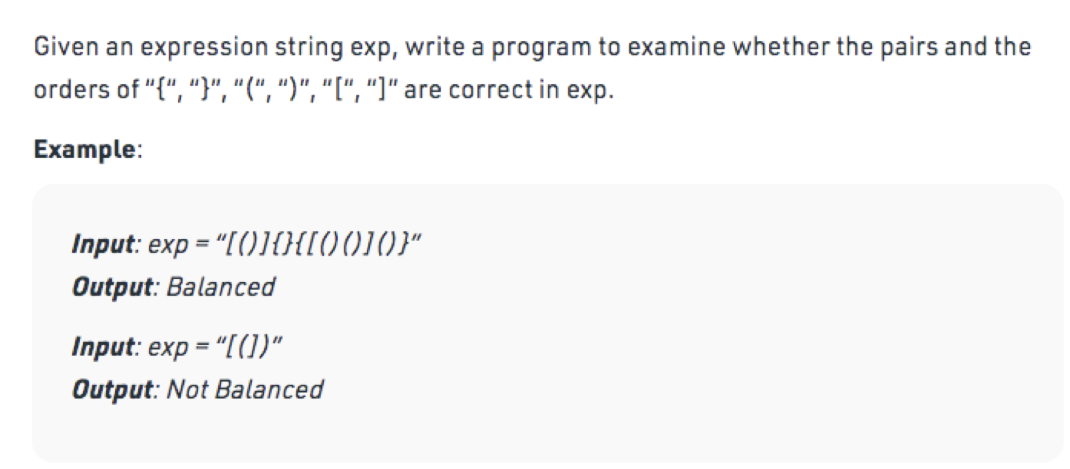

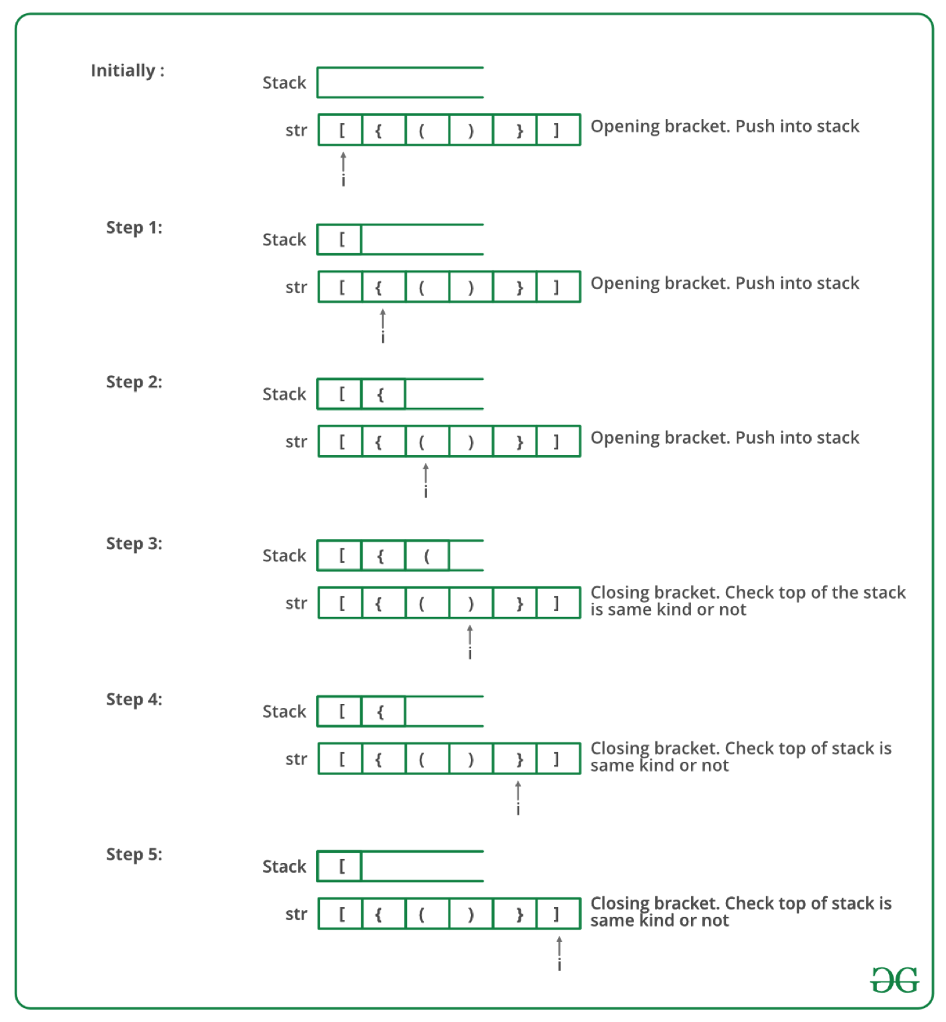

## Solution

<https://replit.com/@rohitbhardwaj/Stack-problems#BalancedBrackets.java>